**PIZZA SALES SQL QUERIES**

1. **KPI’S**
2. **Total Revenue:**

SELECT SUM(total_price) AS Total_Revenue FROM pizza_sales;

***Output:***

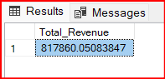

1. **Average Order Value**

SELECT (SUM(total_price) / COUNT(DISTINCT order_id)) AS Avg_order_Value

FROM pizza_sales;

***Output:***

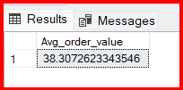

1. **Total; Pizzas Sold**

SELECT SUM(quantity) AS Total_pizza_Sold FROM pizza_sales;

***Output:***

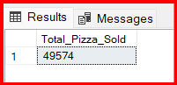

1. **Total Orders**

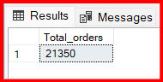SELECT COUNT(DISTINCT order_id) AS Total_orders FROM pizza_sales;

***Output:***

1. **Average Pizzas Per Order**

SELECT CAST(CAST(SUM(quantity) AS DECIMAL(10,2)) /

CAST(COUNT(DISTINCT order_id) AS DECIMAL(10,2)) AS DECIMAL(10,2))

AS Avg_Pizzas_per_order

FROM pizza_sales;

***Output:***

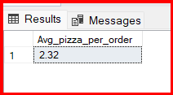

1. **Daily Trend for Total Orders**

SELECT DATENAME(DW, order_date) AS order_day, COUNT(DISTINCT order_id) AS total_orders

FROM pizza_sales

GROUP BY DATENAME(DW, order_date);

***Output:***

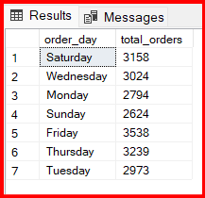

1. **Hourly Trend for Orders**

SELECT DATEPART(HOUR, order_time) as order_hours, COUNT(DISTINCT order_id) as total_orders

from pizza_sales

group by DATEPART(HOUR, order_time)

order by DATEPART(HOUR, order_time);

***Output:***

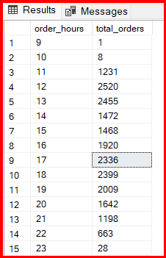

1. **% of Sales by Pizza Category**

SELECT pizza_category, CAST(SUM(total_price) AS DECIMAL(10,2)) AS Total_Revenue,

CAST(SUM(total_price) * 100 / (SELECT SUM(total_price) from pizza_sales) AS DECIMAL(10,2)) AS PCT

FROM pizza_sales

GROUP BY pizza_category;

***Output:***

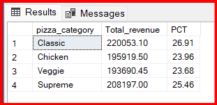

1. **% of Sales by Pizza Size**

SELECT pizza_size, CAST(SUM(total_price) AS DECIMAL(10,2)) AS Total_Revenue,

CAST(SUM(total_price) * 100 / (SELECT SUM(total_price) from pizza_sales) AS DECIMAL(10,2)) AS PCT

FROM pizza_sales

GROUP BY pizza_size

ORDER BY pizza_size;

***Output:***

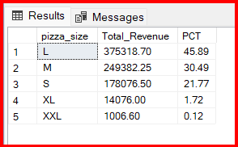

1. **Total Pizza Sold by Pizza Category**

SELECT pizza_category, SUM(quantity) as Total_Quantity_Sold

FROM pizza_sales

WHERE MONTH(order_date) = 2

GROUP BY pizza_category

ORDER BY Total_Quantity_Sold DESC;

***Output:***

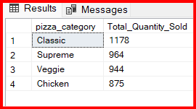

1. **Top 5 Best Sellers by Total Pizza Sold**

SELECT TOP 5 pizza_name,sum(quantity)AS Total_pizza_sold

FROM pizza_sales

group by pizza_name

order by Total_Pizza_Sold DESC;

***Output:***

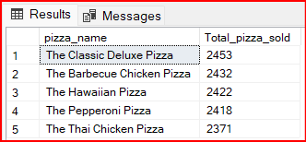

1. **Bottom 5 Best Sellers by Total Pizza Sold**

SELECT Top 5 pizza_name,sum(quantity)AS Total_Pizza_Sold

FROM pizza_sales

GROUP BY pizza_name

ORDER BY Total_Pizza_Sold ASC;

***Output:***

